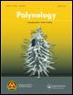**Palynology**

**ISSN: (Print) (Online) Journal homepage:** [**https://www.tandfonline.com/loi/tpal20**](https://www.tandfonline.com/loi/tpal20)



**Pollen sources of *Tetragonula biroi* (Friese, 1898) (Hymenoptera: Apidae, Meliponini) in two agroecosystems in Nagcarlan, Laguna, Philippines**

**Wilfredo B. Barrera Jr. , Joepet V. Brosas & Mar D. Sacil**

**To cite this article:** Wilfredo B. Barrera Jr. , Joepet V. Brosas & Mar D. Sacil

(2020): Pollen sources of *Tetragonula biroi* (Friese, 1898) (Hymenoptera: Apidae,Meliponini) in two agroecosystems in Nagcarlan, Laguna, Philippines, Palynology, DOI: [10.1080/01916122.2020.1789773](https://www.tandfonline.com/action/showCitFormats?doi=10.1080/01916122.2020.1789773)

**To link to this article:** <https://doi.org/10.1080/01916122.2020.1789773>



Accepted author version posted online: 30

Jun 2020.

Published online: 28 Jul 2020.



[Submit your article to this journal](https://www.tandfonline.com/action/authorSubmission?journalCode=tpal20&show=instructions) 



Article views: 17



[View related articles](https://www.tandfonline.com/doi/mlt/10.1080/01916122.2020.1789773) 



[View Crossmark data](http://crossmark.crossref.org/dialog/?doi=10.1080/01916122.2020.1789773&domain=pdf&date_stamp=2020-06-30)



Full Terms & Conditions of access and use can be found at

<https://www.tandfonline.com/action/journalInformation?journalCode=tpal20>



PALYNOLOGY

<https://doi.org/10.1080/01916122.2020.1789773>



Pollen sources of Tetragonula biroi (Friese, 1898) (Hymenoptera: Apidae, Meliponini) in two agroecosystems in Nagcarlan, Laguna, Philippines

Wilfredo B. Barrera, Jr. , Joepet V. Brosas and Mar D. Sacil

Department of Mathematics and Natural Sciences, College of Arts and Sciences, Southern Luzon State University, Lucban, Quezon, Philippines

ABSTRACT

Bee bread samples from the hives of Tetragonula biroi managed in agricultural and agroforest sites in Nagcarlan, Laguna, Philippines were analyzed through light microscopy during the wet season from June to November. A total of 31 pollen types, belonging to 20 botanical families were identified as pollen sources of T. biroi. Adonidia merrilli Becc. and Cocos nucifera L. were consistent predominant pollen sources (>45%) in both sites. The other predominant pollen types in the agricultural site were Arecaceae type 1, Fabaceae type and Marantaceae type, and Ipomoea sp. in the agroforest site. A decreasing number of pollen types were observed from early to late wet months of the study period. Though both sites provide a wide array of pollen sources for T. biroi, the presence of long-blossoming crops resulted in the homogenization of pollen types in the hive. This study highlights the importance of crop diversity and surrounding natural vegetation in the agricultural landscape in providing various pollen sources for pollinators like T. biroi.

KEYWORDS

Agroforest; agricultural plants; beekeeping; foraging; pollen types; stingless bee; Philippines

1. Introduction

Meliponiculture is the term used for stingless beekeeping (Moo-Valle 2018; Vieira et al. 2020). It is one of the economic activities that could exert a positive influence in the ecosys-tem by flower pollination of bees. Managed bees are import-ant in the pollination of agricultural crops (Villanueva-Gutierrez et al. 2015) and wild plants. Through proper bee-keeping management, income can be generated through honey, pollen and propolis production without affecting other ecosystem processes (Almazol and Cervancia 2014).

Though beekeeping industry is increasing in the Philippines, most of the traditional beekeepers are unaware of the plants used by stingless bees to maintain their hives. Beekeeping could play an important role in the conservation of forest and agricultural systems. However, there is still a shortage of gap in knowledge about the pollen sources of stingless bees that can be a basis to assess the potential or suitability of an area for beekeeping (Almazol and Cervancia 2014).

There are at least seven species of stingless bees in the Philippines. Among them, Tetragonula biroi is commonly used in beekeeping (Cervancia et al. 2012; Balderas 2016). Locally known as “lukot”, T. biroi is one of the indigenous bees in the Philippines (Cervancia 2018; Cervancia and Fajardo 2018). It belongs to the tribe Meliponini, subfamily Apinae, family Apidae, under the order Hymenoptera (Rahman et al. 2013). In large-scale crop pollination, T. biroi is used because it can eas-ily be managed (Cervancia et al. 2012).

Pollen is the main source of proteins, free amino acids, lipids, vitamins and minerals for stingless bees (Nicolson 2011). Depending on the availability of food, bees tend to behave as generalists or specialists (Biesmeijer and Slaa 2006; Roubik and Patino~ 2013). In this context, stingless bees are regarded as generalists in utilizing their floral resources (Nagamitsu and Inoue 2005) and prefer to collect pollen, water, nectar and resin as resources (Abou-Shaara 2014). Though stingless bees are commonly regarded as generalists in flower visitation, in reality, they may have intricate yet scarcely appreciated organized ecological interactions within their foraging range, involving the local flora, landscape ele-ments and many organisms (Roubik and Patino~ 2018). In stingless bees, there is a need for a continuous supply of pollen in the form of bee bread, for brood production and stability of the hive (Adams et al. 1981; Terrell and Batra 1984). Pollen grains from the bee bread samples can be studied to understand the behavior and plant preference of bees (Cortopassi-Laurino et al. 1991; Vossler et al. 2018). Identification of the floral resources used by bees is an important tool for the development of conservation strat-egies and to understand the potential effects of the loss of populations of pollinators specifically the ecosystem services associated with pollination (Aguiar et al. 2013).

Stingless bees are one of the most important bee-pollina-tors in the tropics. Their presence is essential in pollinating wild species of plants in the forest and crucial to the produc-tion of agricultural crops in farmed areas (Heard 1999; Reyes-Gonzalez et al. 2014). FAO (2007) reported that the loss of

CONTACT Wilfredo B. Barrera Jr.  barrerawilfredojr@gmail.com  Department of Mathematics and Natural Sciences, College of Arts and Sciences, Southern Luzon State University, Quezon Avenue, Brgy. Kulapi, Lucban, Quezon 4328 Philippines.

2020 AASP – The Palynological Society

Published online 28 Jul 2020

2  W. B. BARRERA ET AL.

stingless bees can lead to food inadequacy and threat in bio-diversity indicating their strong influence in the ecosystem as a whole in terms of ecological stability, genetic variation in the plant community and floral diversity. Spatio-temporal changes in the availability of pollen resources can greatly affect bee colonies. Pollen scarcity in particular and the lack of flowering plants as pollen sources for bees contribute to weakening colonies (Pasquale et al. 2016). Thus, an under-standing of the bee-foraged plants helps to better under-stand their natural environment and conserve and maintain their biodiversity (Almeida Braga et al. 2012). Balderas (2016) also pointed out that identification of plants visited by sting-less bees for pollen and nectar and their blooming pattern is useful in the selection of sites suited for meliponiculture.

Nagcarlan is a municipality in the Province of Laguna in the Philippines that is rich in biodiversity. It covers some parts of Mt. Banahaw, a protected landscape characterized by high species diversity including endemic species of plants and animals (Banaticla and Buot 2005; Gascon et al. 2013; de Guia et al. 2018; Barrera et al. 2019). Nagcarlan also provides wide array of resources (i.e. pollen and nectar) for different pollinators such as stingless bees due to its diverse habitats such as agroforest, agricultural, grassland and home gardens.

We introduced hives of T. biroi to investigate the dynam-ics of pollen sources in two selected agroecosystems in Nagcarlan, Laguna. Specifically, our study aimed to identify the pollen sources of T. biroi managed in agricultural and agroforest areas during the wet season from June to November. Our results may provide an idea for the potential-ity of stingless beekeeping in the areas hence offers an avenue for a possible sustainable community-based liveli-hood for the local people. This study can also provide initial information for the development of conservation plans and sustainable management of stingless bees as one of the components of biodiversity.

2. Materials and methods

2.1. Study sites

The study was conducted in two agroecosystems in Nagcarlan, Laguna, Philippines, approximately 5.02 km apart. The first site is an agricultural area, located at 14 060 29.0” North and 121 250 05.7” East, and has an elevation of 343 masl. It is characterized mainly by agricultural crops such as banana, beans, cucumber and coconut, and some species of shrubs, weeds and grasses. The second site is an agroforest area, located at 14 040 31.6” North and 121 260 52.9” East, and has an elevation of 695 masl. It is approximately 100 m from the entrance of Mt. Banahaw protected landscape. Generally, the site is characterized by native species of trees and shrubs and planted with agricultural crops such as banana, beans, cabbage, cassava, chayote, coconut, cucum-ber, radish, sweet potato and tomato in its vicinity.

Nagcarlan, Laguna has a tropical climate, classified as Am

in the Koppen€-Geiger climate classification. During the study period, the mean monthly temperature ranges from 23 C to 28.5 C in the agricultural site and 21.5 C to 26 C in the

agroforest site with an average annual rainfall of 2387 mm and relative humidity of 86.33% (climate-data.org).

2.2. Introduction of strong bee hives

Due to the limited number of colonies, only one beehive was introduced in the selected sites to determine the pollen sources of T. biroi. The beehive entrance was directed towards the East because sunlight entices the bees to be active (Rabajante and Fajardo 2009). Since the beehive was placed in only one direction, our study was limited only to pollen sources collected by T. biroi at 45 angle. The hive was placed in a well-drained area, safe from flash floods and protected against strong winds and heavy rains as recom-mended in the Philippine National Standard for Code of Good Beekeeping Practices (2016).

2.3. Collection of bee bread

This study was conducted during the wet season where there is a high precipitation. To minimize disturbance in the beehive, the collection of bee bread was done every two weeks from June to November. Bee bread ( 25 g) near the entrance of the hive (same location for every collection) was collected in the morning (07:00 to 11:00) using a clean stain-less steel spoon, kept in a labeled Falcon tube, and stored in a freezer until pollen processing and analysis.

2.4. Processing of pollen samples and microscopic observation

The bi-monthly bee bread samples were combined together to produce a monthly sample of approximately 50 g. The samples were processed using the acetolysis method (Erdtman 1960; Ferreira and Absy 2018) with some modifica-tions. Glacial acetic acid was added to the homogenized pol-len samples for 10 minutes and centrifuged at 1800 rpm for 10 minutes. The supernatant was discarded and 4 mL of ace-tolysis mixture was added. The samples were placed in a water bath for 5 minutes and cooled for few minutes before centrifugation at 1800 rpm for 10 minutes. The supernatant was discarded, re-suspended two times with distilled water and centrifuged again at 1800 rpm for 5 minutes. The super-natant was discarded and 3 mL of 70% ethyl alcohol was added to dissolve the centrifuged pollen samples. After ace-tolysis, pollen slides were prepared for microscopic examin-ation. Pollen sample was mounted in a microscope slide using glycerine jelly and Safranin O. The pollen grains were photographed at 400x magnification using Applied Vision 4 compound light microscope with an attached camera. The pollen grains were initially identified by using relevant litera-tures and pollen atlas (Kiew and Muid 1991; Hesse et al. 2009) and then verified by an expert. In-bloom flowers in a 300 m phenology transect at the vicinity of the beehive were also recorded and collected on a weekly basis for pollen ref-erence (Balderas 2016; Ferreira and Absy 2018).

2.5. Diversity analysis of pollen sources

Three sub-replicates for each monthly sample were mounted in a microscope slide. A total of 900 pollen grains per sample (300 pollen grains per slide) were counted to classify the fre-quency of occurrence of the pollen types. The pollen grains were classified according to Louveaux et al. (1978) such as: >45% – predominant pollen, 16–45% – secondary pollen and 3–15% – important minor pollen. We did not include the pollen types with a frequency of <3% in the analysis and classified them as minor pollen and nectar sources only if entomophilous (Junqueira et al. 2017; Vieira et al. 2020) or minor pollen (Louveaux et al., 1978) if anemophilous. Pollens that cannot be identified at the genus or species level were identified at the family level and designated as pollen types (De Klerk and Joosten 2007; Rezende et al. 2019; Machado et al. 2020; Vieira et al. 2020). To determine the pollen niche breadth, Shannon diversity index and Pielou’s evenness index were computed using PAST (Paleontological Statistics) soft-ware version 3.26 (Hammer et al. 2001) while Jaccard’s coeffi-cient (J’) was used to determine the similarity in pollen sources between the two sites.

3. Results

Throughout the duration of the study, a total of 31 pollen types belonging to 20 botanical families and one unknown pollen type were identified from the bee bread samples of T. biroi (Figure 1). The entomophilous pollen types such as Arecaceae type 3, Euphorbia sp., Loranthaceae type, Rhododendron subsessile Rendle and Terminalia catappa L. has a frequency of <3%, therefore classified as minor pollen and nectar sources only. Similarly, the anemophilous pollen types such as Cyperaceae type 1 and Saccharum sp. were classified as minor pollen sources. Adonidia merrilli and Cocos nucifera were the predominant pollen types both in the agri-cultural and agroforest sites. The other predominant pollen types in the agricultural site were Arecaceae type 1, Fabaceae type and Marantaceae type, and Ipomoea sp. in the agroforest site (Figure 2a,b). All other identified pollen types were classified as important minor pollen sources or secondary pollen sources. The two sites exhibited low to a moderate similarity in terms of pollen sources (J’ ¼ 0.375). Pollen types found exclusively in the agroforest site was rela-tively higher compared to the agricultural site. We identified five pollen types found only in the agricultural site though only one of them (i.e. Musa sp.) is an agricultural crop. On the other hand, the agroforest site has 10 unique pollen types, wherein two of them (i.e. Ipomoea sp., Sechium edule (Jacq.) Sw.) are agricultural crops.

At the start of the wet season (June), 15 different pollen types were utilized by T. biroi. There was a great increase in pollen types in July and a steady decline throughout the remaining months of the study period. The agroforest site exhibited a higher diversity of pollen sources in the first four months (June to September) than the agricultural site. In contrast, a higher diversity of pollen sources was observed in the agricultural site in the late wet months (October to

PALYNOLOGY  3

November). The diversity of pollen sources in both sites var-ied throughout the study period (Figure 3) with the highest value recorded in the month of July (H’agroforest site ¼ 1.870; H’ agricultural site ¼ 1.843). Likewise, the lowest value was recorded in the month of November (H’agroforest site ¼ 0.9842; H’ agricultural site ¼ 1.136) where the precipitation was highest (351 mm) (Figure 3). In the agroforest site, we found the highest and lowest evenness in pollen sources in the month of September (0.5182) and October (0.3207) respectively, while it was recorded in October (0.6576) and June (0.389) respectively, in the agricultural site. Overall, a decreasing number of pollen types from the early wet month (June) to the late wet month of the year (November) was observed.

Tetragonula biroi diversified its pollen sources in an envir-onment with high plant diversity (agroforest) while maintain-ing a constant pollen source. In the agricultural site, a total of 14 pollen sources were identified which was divided into three distinct groups by cluster analysis (Figure 4a). Group 1 comprised the important minor pollen source with seven pollen types, Group 2 comprised the secondary pollen source with two pollen types and Group 3 comprised the predomin-ant pollen source with five pollen types. Similarly, a total of 19 pollen sources were identified in the agroforest site. Cluster analysis classified these pollen sources into four dis-tinct groups according to their frequency of occurrence (Figure 4b). The secondary pollen source has two groups such as Group 1 with two pollen types and Group 3 with four pollen types. On the other hand, Group 2 comprised the important minor pollen source with 10 pollen types. Lastly, the predominant pollen source comprised Group 4 with three pollen types.

4. Discussion

Studies on pollen identification have revealed the import-ance of botanical diversity as food sources of stingless bees (Absy et al. 2018). Based on pollen frequency classes, we observed that T. biroi has a strong preference for Arecaceae as its main source of pollen, especially the cultivated species Cocos nucifera. Cervancia (2018) listed C. nucifera as one of the most important pollen and nectar sources in the Philippines. Balderas (2016) also found C. nucifera in the pol-len-pot samples of T. biroi in Bicol Region, Philippines, while in the Central Amazon, Marques-Souza et al. (2007) found C. nucifera being used by stingless bees. In Panama, Roubik and Patino~ (2018) regarded palms as important pollen sour-ces for stingless honey bees due to their large pollen size.

Our results showed that the foraging of T. biroi for pollen is not only limited to entomophilous plants. Instead, it appears that pollen collection is determined by the presence of plants in the area that are flowering. This is supported by the presence of anemophilous pollen types of Poaceae and Cyperaceae in the bee bread samples from both sites and by the similarity between pollen grains from the hive and the flowering plants we collected in the phenology transect. However, Vieira et al. (2020) cited that the presence of pollen types belonging to plant species that are poor in nectar

4  W. B. BARRERA ET AL.

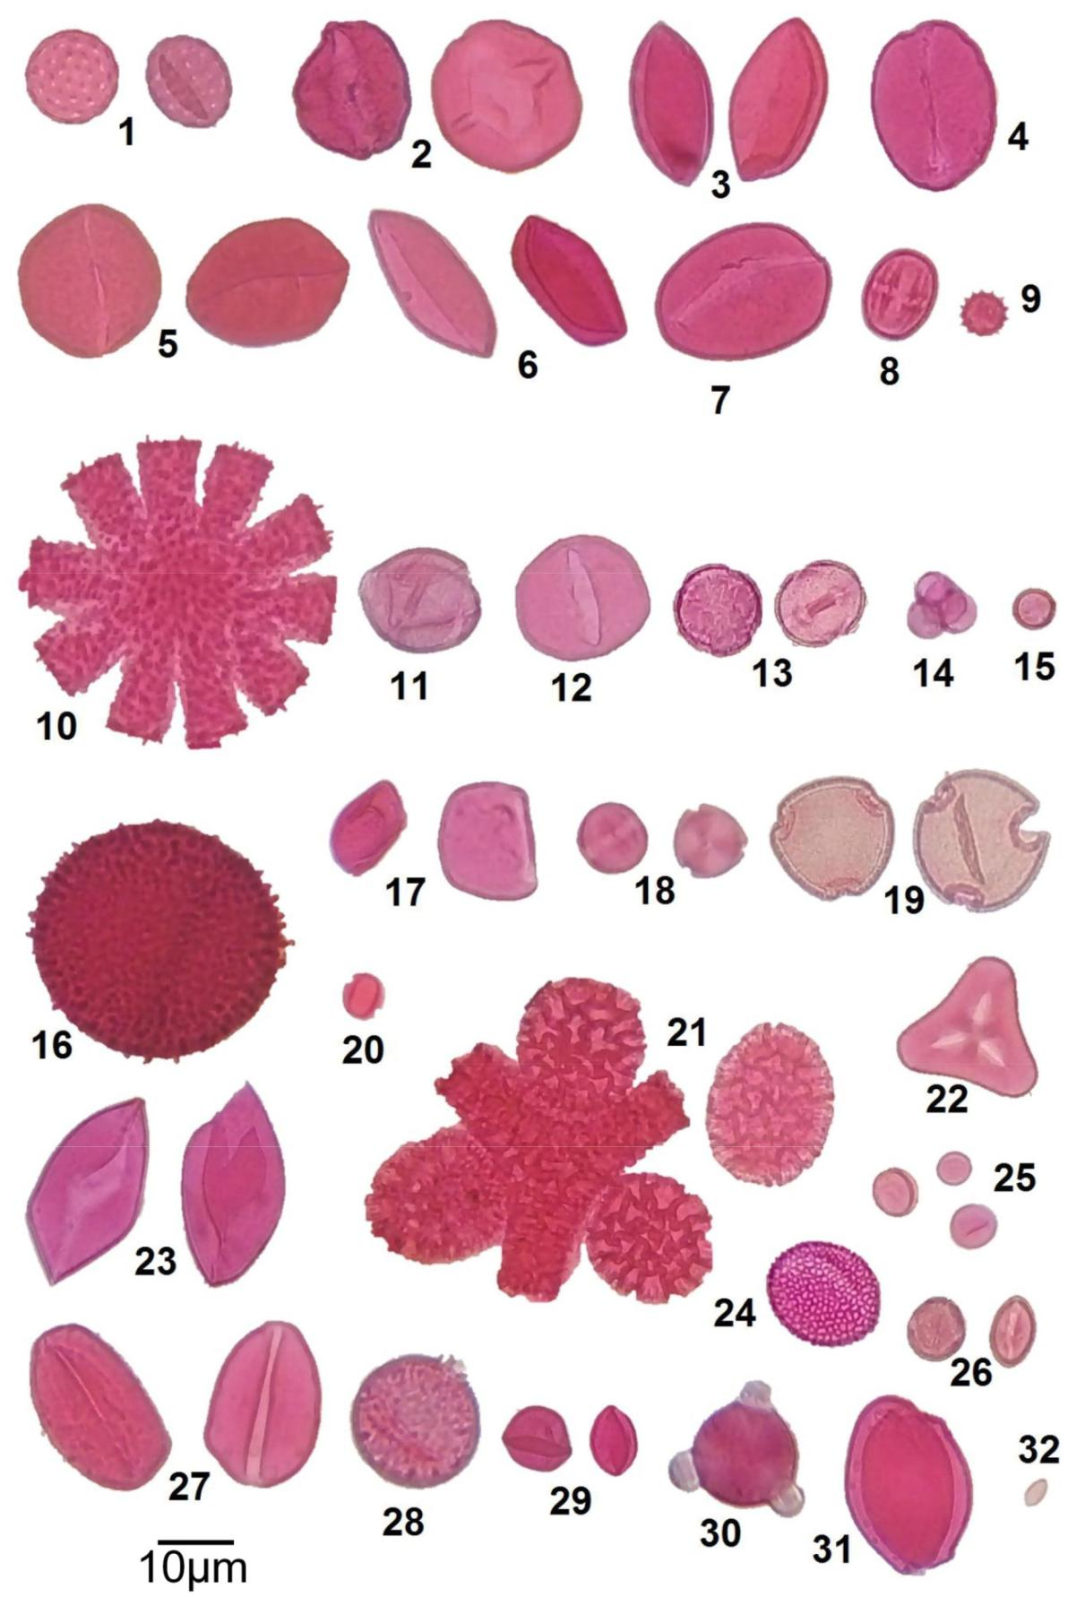

Figure 1. Photomicrographs of pollen collected by Tetragonula biroi in Nagcarlan, Laguna: (1) Chenopodium sp., (2) Apocynaceae type, (3) Arecaceae type 1, (4) Arecaceae type 2, (5) Arecaceae type 3, (6) Cocos nucifera, (7) Adonidia merrilli, (8) Terminalia catappa, (9) Ipomoea sp., (10) Sechium edule, (11) Cyperaceae type 1,

1. Cyperaceae type 2, (13) Ericaceae type, (14) Rhododendron subsessile, (15) Fabaceae type, (16) Euphorbia sp., (17) Albizia sp., (18) Desmodium sp., (19) Euchresta formosana, (20) Miconia sp., (21) Intsia acuminata, (22) Loranthaceae type, (23) Maranthaceae type, (24) Glochidion sp., (25) Musa sp., (26) Piperaceae type, (27) Graminae type, (28) Saccharum sp., (29) Potamogeton sp., (30) Rosaceae type, (31) Urticaceae type, (32) unidentified. Pollen grains were processed using the acetol-ysis method, mounted using Safranin O glycerine jelly, and viewed at 400x magnification.

suggests possible contamination by the pollen stored in the food pots present inside the colony.

The high pollen count of two melliferous plants such as A. merrilli and C. nucifera could be attributed to their long-blossoming habit (Balderas 2016) and abundance of these plant species in the study sites most especially in the agricultural site which is a coconut plantation. Fabaceae are considered import-ant pollen sources for stingless bees due to their diverse species

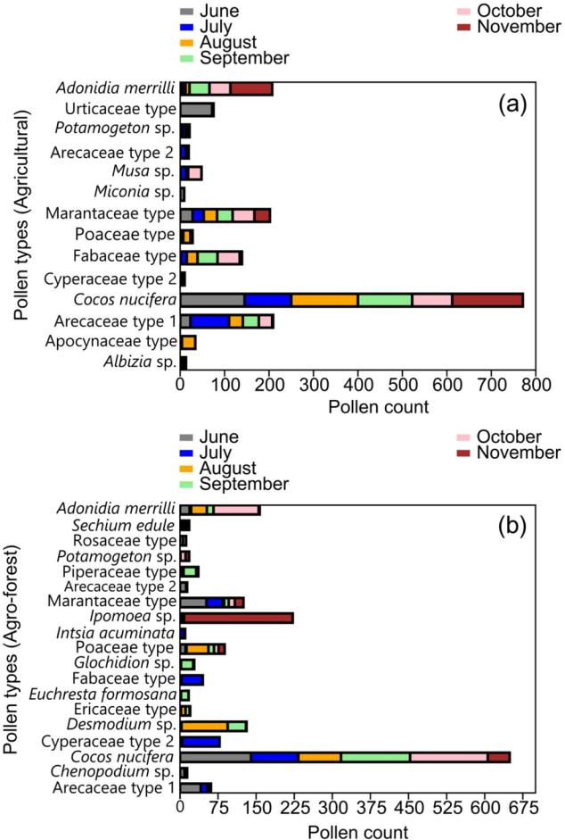

Figure 2. Frequency of occurrence of different pollen types identified in the bee bread samples of Tetragonula biroi in the agricultural (a) and agro-forest (b) sites throughout the study period (June to November).

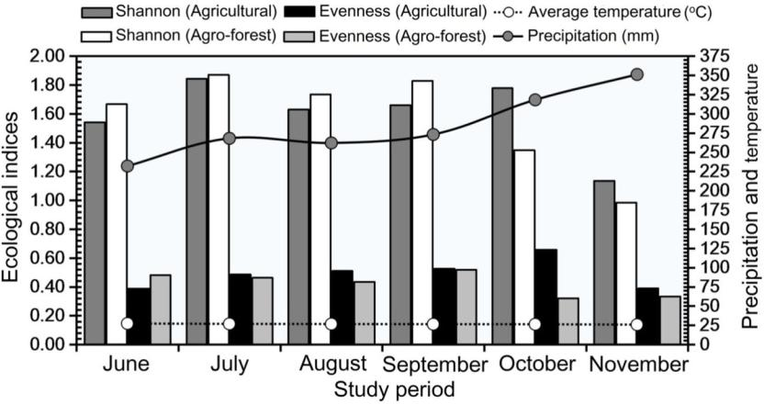

PALYNOLOGY  5

that have a long blooming period (Marquez-Souza et al. 1996). This was confirmed by the presence of plantations of common bean in both study sites. In the agricultural site, Musa sp. is one of the unique pollen types. This species was observed flowering in the vicinity of the hive. Marquez-Souza et al. (1996) stated that stingless bees prefer medium to large pollen grains. Thus, the collection of small pollen of Musa sp. might suggest the need for a continuous supply of pollen for T. biroi especially during the months of excessive rainfall (October to November). Krishnan et al. (2019) also reported stingless bees foraging on several species of Musa in the Indo-Pacific region and regarded them as non-pest species. In the agroforest site, S. edule and Ipomoea sp. are consistent pollen sources for T. biroi. These crops are one of the economic crops of the local people inhab-iting the area and therefore one of the crops being planted throughout the cropping cycle. Sechium edule and Ipomoea flowers abundantly throughout the year in tropical countries depending on cropping season and is considered as good sour-ces of pollen and nectar for stingless bees (McGregor 1976; Wilson et al. 1989; Engels and Jeffrey 1993; Antonini et al. 2006).

The existence of different habitat types in a given landscape affects the food collection (Aleixo et al. 2017) and resources availability of stingless bees. In the agricultural landscape and agroforestry systems, the role of native bees including stingless bees as pollinators has already been proven (Heard 1999; Slaa et al. 2006; Garibaldi et al. 2013; Sritongchuay et al. 2016; Absy et al. 2018). Our results are consistent with the expectation that bees will collect more diverse pollen in the agroforest than agricultural sites. There are fewer species of plants near agricul-tural areas, but more pollen from the crop species, such that the abundance of single-species pollen will increase, but the diversity will decrease (Pope and Jha 2018). We observed that T. biroi tends to homogenize and collect pollen sources in simi-lar proportions in the agricultural area as indicated by higher evenness compared to agroforest. In the agroforest site, the close proximity to protected landscape and the presence of in-bloom agricultural plants at the vicinity, offer T. biroi diverse pollen sources. Ricketts (2004) found out that in a coffee plan-tation, sites that are near the forest received roughly twice the number of pollen grains. This suggests that forest remnants enhance pollinator activity in surrounding agricultural fields. Interestingly, though we observed higher diversity of pollen

Figure 3. Diversity (H’-Shannon) and Evenness (J’) indices of pollen sources of Tetragonula biroi in the agricultural and agro-forest sites throughout the study period (June to November) in relation to climatic factors such as temperature ( C) and precipitation (mm).

6  W. B. BARRERA ET AL.

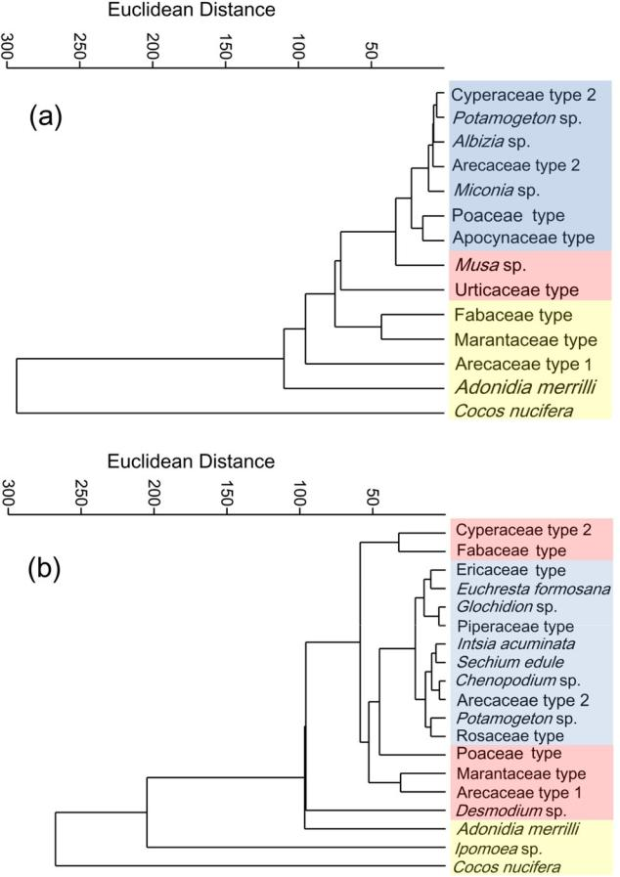

Figure 4. Dendrogram generated from cluster analysis using Euclidean distance of the pollen sources of Tetragonula biroi in the agricultural (a) and agro-forest

1. sites. The dendrogram was generated using the unweighted pair group method with arithmetic mean (UPGMA) algorithm. The different clusters obtained according to pollen frequency of occurrence are emphasized with col-ors: blue–important minor pollen source (3–15%), red–secondary pollen source (16–45%), yellow–predominant pollen source (>45%).

sources in the agroforest, T. biroi still preferred two to three species of cultivated plants as its main source of pollen. In an upland and lowland ecosystem in the Philippines, Balderas (2016) reported that the pollen spectrum of T. biroi showed a linear relationship with the bloom pattern of plants in the area and though the sites have various pollen sources for T. biroi, it preferred particular pollen over the others. Several authors pointed out that regardless of their huge generalist potential, stingless bees tend to rely upon a few continuous sources of pollen throughout the year exploiting only the most profitable ones (Eltz et al. 2001; Absy et al. 2018; Vossler et al. 2018).

Aleixo et al. (2017) stated that in stingless bee colonies, food collection is influenced by biotic factors such as differences in floral resource availability and abiotic factors such as tempera-ture, rainfall and habitat types. We observed the highest diver-sity of pollen sources during the early wet month (July) both in the agricultural and agroforest sites. During the early wet sea-son, many plants in the tropics are typically in-bloom, offering many floral choices for bees (Murali and Sukumar 1994; Hamann 2004; Maia-Silva et al. 2015). In this study, the lowest diversity in pollen sources both in the agricultural and agrofor-est sites can be attributed to elevated rainfall during the month of November. It was pointed out by van Schaik et al. (1993)

that rainfall influences the abundance of plant individuals that provide pollen, thus resource availability is strongly associated with seasonal variations in rainfall. The foraging behavior of stingless bees can also be indirectly affected by rainfall. For example, during elevated rainfall, stingless bees find it difficult to forage (Sawatthum and Kumlert 2015; Keppner and Jarau 2016) thus forcing them to rely on pollen sources that are near their nesting colony. In rural and semi-urban areas of West Bengal, India, Bisui et al. (2019) reported the highest diversity in pollen sources of stingless bees during the months of July and August and lowest during the months of December and January.

Farming practices could also play an important role in ensuring the diversity of pollen sources available for pollina-tors like stingless bees. Nicholls and Altieri (2013) stated that crop monocultures sacrifice floral diversity. From our obser-vation, monoculture is not being practiced in the study sites. The small-scale farmers in the study sites plant several crops throughout the year offering various pollen sources for T. biroi during the cropping cycle. Hass et al. (2018) cited that crop diversity is expected to increase pollinator abundance, species richness and pollination services through comple-mentary resource provisioning. Intercropping (e.g. cucumber with tomato) is also being practiced by the farmers in the area which is a good farming practice to boost pollinators. Despite the observed differences in pollen use of T. biroi in the two study sites, our results reveal the importance of the non-crop plant species surrounding the agricultural area in sustaining the bee colony especially during the time when the crops are not yet flowering. This somehow strengthens the suitability of an agroforest ecosystem in beekeeping and in the maintenance of pollinators including T. biroi.

The diversity of plant resources is usually closely linked to habitat quality and composition and thus foraging land-scapes (Williams and Kremen 2007). Kaluza et al. (2017) cited that natural or semi-natural habitats (agroforest) are typically richest in plant species and thus resources collected by bees, while habitats altered by humans for agriculture or intense urbanization often have reduced plant diversity and thus provide only limited resources. Even though this is usually true, we cannot rule out the indispensable role of cultivated plants in the agricultural landscape as pollen sources for stingless bees. With this, the sustainable management of agricultural landscapes must therefore consider a variety of strategies for the establishment and permanence of pollina-tors in cultivated areas (Patrıcio-Roberto and Campos 2014). Pollinator friendly crop areas must be planned to be sur-rounded by diverse natural nearby environments, guarantee-ing year-long pollen resources available for the maintenance of a bee colony (Machado et al. 2020).

5. Conclusions

The two agroecosystems such as agricultural and agroforest areas in Nagcarlan, Laguna seem to provide diverse pollen sources for T. biroi however, it still preferred the long blos-soming cultivated plants such as C. nucifera as a constant pollen source. The diversity of pollen in the bee bread

samples confirmed that T. biroi is a polylectic species that visits multiple flowering plants for the source of pollen. There is a decreasing number and diversity of pollen sources in the study sites throughout the study period which may suggests influence of rainfall in the availability of food sour-ces for T. biroi. The identified pollen sources of T. biroi should be conserved or cultivated to reduce the vulnerability of this species and to increase the chance of successful beekeeping in the area. Our preliminary results confirmed that Nagcarlan, Laguna is somehow suitable for stingless beekeeping how-ever, community-based studies should be conducted consid-ering biotic and abiotic factors such as habitat types, season, number and positioning of colonies, and yield and physico-chemical characteristics of honey among others.

Acknowledgments

The authors would like to thank Forester Eraldwin A. Dimailig for provid-ing stingless bee colonies and Dr. Analinda C. Manila-Fajardo for verifica-tion of the pollen samples. The Local Government Units (LGU) of Brgy. Silangan Lazaan and Brgy. San Francisco, Nagcarlan, Laguna, Philippines are also greatly acknowledged for their permission to conduct our study under their area of jurisdiction. The authors are also grateful to the Department of Mathematics and Natural Sciences-Southern Luzon State University for granting permission to use the facility for laboratory analysis.

Disclosure statement

The authors declared no conflict of interest.

Notes on contributors

WILFREDO B. BARRERA, JR. is a licensed professional teacher and cur-rently an instructor at the Department of Mathematics and Natural Sciences at Southern Luzon State University, Philippines. He is primarily interested in pollination biology, local adaptations and phenotypic vari-ability in plants, food and nutrition security, genetic diversity of crops, and conservation and utilization of plant genetic resources for food and agriculture. He holds a Bachelor’s degree in Biology and a Masters’s degree in Genetics (minor in Plant Genetic Resources Conservation and Management). He was an MS Research Scholar at the International Rice Research Institute in 2015, and a recipient of the Food Security Center Summer School held in Costa Rica in 2018 and the ASEAN-India Research Training Fellowship in 2019 at the Indian Institute of Rice Research, Hyderabad, India. Currently, he is doing his Ph.D. in Genetics and Plant Breeding.

JOEPET V. BROSAS has a Bachelor’s degree in Biology at Southern Luzon State University in the Philippines and is currently working in the Newborn Screening Center- Southern Luzon, Philippines. He was born and raised in Nagcarlan, Laguna, Philippines where the study was con-ducted. He is currently applying for graduate studies at the University of the Philippines-Baguio with a specialization in conservation and restor-ation ecology.

MAR D. SACIL has a Bachelor’s degree in Biology at Southern Luzon State University, Philippines. He took professional education units and eventually passed the board licensure examination. He has been teach-ing Science and Research subjects in the Laboratory School of the said university for two years now and is currently doing his graduate studies at the University of the Philippines Diliman, Quezon City.

ORCID

Wilfredo B. Barrera  http://orcid.org/0000-0003-0990-7963

PALYNOLOGY  7

References

Abou-Shaara HF. 2014. The foraging behavior of honey bees, Apis melli-fera: a review. Veterinarnı Medicına. 59(1):1–10.

Absy ML, Rech AR, Ferreira MG. 2018. Pollen collected by stingless bees: a contribution to understanding Amazonian biodiversity. In: Vit P, Pedro SRM, Roubik DW, editors. Pot-pollen in stingless bee melittol-ogy. Cham (CH): Springer International Publishing; p. 29–46.

Adams DE, Perkins E, Estes JR. 1981. Pollination system in Paspalum dila-tatum Poir (Poaceae): an example of insect pollination in temperate grass. American Journal of Botany. 68(3):389–394.

Aguiar CML, Santos GM, Martins CF, Presley SJ. 2013. Trophic niche breadth and niche overlap in a guild of flower-visiting bees in a Brazilian dry forest. Apidologie. 44(2):153–162.

Aleixo KP, Menezes C, Imperatriz Fonseca VL, da Silva CI. 2017. Seasonal availability of floral resources and ambient temperature shape sting-less bee foraging behavior (Scaptotrigona aff. depilis). Apidologie. 48(1):117–127.

Almazol AE, Cervancia CR. 2014. Pollen sources of bees in Pagbilao man-grove ecosystem. Philippine Entomologist. 28(2):155–170.

Antonini Y, Costa RG, Martins RP. 2006. Floral preferences of a neotrop-ical stingless bee, Melipona quadrifasciata Lepeletier (Apidae: Meliponina) in an urban forest fragment. Brazilian Journal of Biology. 66(2A):463–471.

Balderas MB. 2016. Pollen spectrum and phenology of stingless bee (Tetragonula biroi Friese) plants. Proceedings of the 3rd International Conference on Agriculture and Forestry; June 1-3; Manila, Philippines.

Banaticla MCN, Buot IE. 2005. Altitudinal zonation of pteridophytes on Mt. Banahaw de Lucban, Luzon Island, Philippines. Plant Ecology. 180(2):135–151.

Barrera WB, De Guzman VJG, Mergilla RR. 2019. Functional adaptations of Begonia oxysperma A.DC and Begonia ramosii Merr. (Begoniaceae) revealed through morpho-anatomical analyses. Philippine Journal of Systematic Biology. 13(1):13–27.

Biesmeijer JC, Slaa J. 2006. The structure of eusocial bee assemblages in Brazil. Apidologie. 37(2):240–258.

Bisui S, Layek U, Karmakar P. 2019. Comparing the pollen forage pattern of stingless bee (Trigona iridipennis Smith) between rural and semi-urban areas of West Bengal, India. Journal of Asia-Pacific Entomology. 22(3):714–722.

Almeida Braga J, Oliveira Sales E, Soares Neto J, Menezes Conde M, Monika Barth O, Lorenzon MC. 2012. Floral sources to Tetragonisca angustula (Hymenoptera: Apidae) and their pollen morphology in a South Brazilian Atlantic forest. Revista de Biologıa Tropical. 60(4): 1491–1501.

Cervancia CR, Fajardo ACJ, Fajardo AM, Lucero RM. 2012. Management of Philippine bees: stingless bees and honey bees. Laguna (PH): University of the Philippines Los Banos; 71 pp.

Cervancia CR. 2018. Management and conservation of Philippine bees. In: Chantawannakul P, Williams G, Neumann P, editors. Asian bee-keeping in the 21st Century. Singapore: Springer; p. 307–321.

Cervancia CR, Fajardo AC. 2018. Stingless bees and crop pollination in the Philippines. In: Roubik DW, editor. The pollination of cultivated plants. A compendium for practitioners. Rome (IT): Food and Agriculture Organization of the United Nations; p. 65–71.

Cortopassi-Laurino M, Knoll FRN, Ribeiro MF, Heemert CV, Ruijter A.

1991. Food plant preferences of Friesella schrottyi. Acta Horticulturae.

288:382–385.

de Guia APO, Realubit NDC, Jaluague J. 2018. Distribution and diet of small nonvolant mammals along elevational gradients of Mt. Banahaw. Philippine Science Letters. 11(01):22–29.

De Klerk P, Joosten H. 2007. The difference between pollen types and plant taxa: a plea for clarity and scientific freedom. Science Journal. 56(3):162–171.

Eltz T, Bruhl A, Vanderkaar SS, Chey V, Linsenmair KE. 2001. Pollen forag-ing and resource partitioning of stingless bees in relation to flowering dynamics in a Southeast Asian tropical rainforest. Insectes Sociaux. 48:273–279.

Engels JMM, Jeffrey C. 1993. Sechium edule (Jacq.) Swartz. In: Siemonsma JS, Kasem Piluek, editors. Plant resources of South-East Asia No 8.

8  W. B. BARRERA ET AL.

Vegetables. Wageningen, Netherlands: Scientific Publishers; p.

246–248.

Erdtman G. 1960. The acetolysis method: a revised description. Svensk Botanisk Tidskrift. 54:561–564.

Ferreira MG, Absy ML. 2018. Pollen niche of Melipona (Melikerria) inter-rupta (Apidae: Meliponini) bred in a meliponary in a terra-firme forest in the Central Amazon. Palynology. 42(2):199–209.

Food and Agriculture Organization (FAO). 2007. Pollinators: Neglected biodiversity of importance to food and agriculture. Rome: Food and Agriculture Organization of United Nations.

Garibaldi LA, Steffan-Dewenter I, Winfree R, Aizen MA, Bommarco R, Cunningham SA, Kremen C, Carvalheiro LG, Harder LD, Afik O, et al. 2013. Wild pollinators enhance fruit set of crops regardless of honey bee abundance. Science (New York, N.Y.). 339(6127):1608–1611.

Gascon CN, Garcia RC, Beltran FN, Faller WC, Agudilla M. 2013. Biodiversity assessment of Mt. Banahaw de Dolores. Asian Journal of Biodiversity. 4(1):23–45.

Hamann A. 2004. Flowering and fruiting phenology of a Philippine sub-montane rainforest climatic factors as proximate and ultimate causes. Journal of Ecology. 92(1):24–31.

Hammer O, Harper DAT, Ryan PD. 2001. PAST: Paleontological statistics software package for education and data analysis. Palaeontologia Electronica. 4(1):1–9.

Hass AL, Kormann UG, Tscharntke T, Clough Y, Baillod AB, Sirami C, Fahrig L, Martin JL, Baudry J, Bertrand C, et al. 2018. Landscape con-figurational heterogeneity by small-scale agriculture, not crop diver-sity, maintains pollinators and plant reproduction in Western Europe. Proceedings of the Royal Society B: Biological Sciences. 285(1872): 20172242.

Heard TA. 1999. The role of stingless bees in crop pollination. Annual Review of Entomology. 44:183–206.

Hesse M, Halbritter H, Zetter R, Webber M, Buchner R, Frosch Rodivo A, Ulrich S. 2009. Pollen terminology: an illustrated handbook. Springer Wien New York.

Moo-Valle H. 2018. Managing and preserving stingless bees. In: Quezada-Euan, JJG, editor. Stingless bees of Mexico. Cham (CH): Springer International Publishing AG; p. 193–242.

Junqueira CN, Rabelo LS, Alves EM, Bastos F, Augusto SC. 2017. Do flex-ible pollen foraging habits of Xylocopa frontalis (Apidae, Xylocopini) contribute to nest management in passion fruit crops? Journal of Apicultural Research. 56(5):646–652.

Kaluza BF, Wallace H, Keller A, Heard TA, Jeffers B, Drescher N, Bluthgen N, Leonhardt SD. 2017. Generalist social bees maximize diversity intake in plant species-rich and resource-abundant environments. Ecosphere. 8(3):e01758.

Keppner EM, Jarau S. 2016. Influence of climatic factors on the flight activity of the stingless bee Partamona orizabaensis and its competi-tion behavior at food sources. Journal of Comparative Physiology. A, Neuroethology, Sensory, Neural, and Behavioral Physiology. 202(9-10): 691–699.

Kiew R, Muid M. 1991. Beekeeping in Malaysia: pollen atlas. Malaysian Beekeeping Research and Development Team. Kuala Lumpur, Malaysia: United Selangor Press.

Krishnan JU, Jayaprakas CA, Harish ER, Rajeswari LS. 2019. Banana (Musa spp.) - an unseen umbrella crop? Insect diversity on Musa spp. Oriental Insects. 1–13.

Louveaux J, Maurizio A, Vorwohl G. 1978. Methods of melissopalynology.

Bee World. 59(4):139–157.

Machado T, Viana BF, da Silva CI, Boscolo D. 2020. How landscape com-position affects pollen collection by stingless bees?. Landscape Ecology. 35(3):747–759.

Maia-Silva C, Hrncir M, da Silva CI, Imperatriz-Fonseca VL. 2015. Survival strategies of stingless bees (Melipona subnitida) in an unpredictable environment, the Brazilian tropical dry forest. Apidologie. 46(5): 631–643.

Marques-Souza AC, Absy ML, Kerr WE. 2007. Pollen harvest features of the Central Amazonian bee Scaptotrigona fuvicutis Moure 1964 (Apidae: Meliponinae), in Brazil. Acta Botanica Brasilica. 21(1):11–20.

Marquez-Souza AC, Moura C, Nelson BW. 1996. Pollen collected by Trigona williana (Hymenopetra: Apidae) in Central Amazon. Revista de Biologia Tropical. 44(2):563–573.

McGregor SE. 1976. Insect pollination of cultivated crops plants.

Washington, DC: US Department of Agriculture.

Murali KS, Sukumar R. 1994. Reproductive phenology of a tropical dry forest in Mudumala, Southern India. The Journal of Ecology. 82(4): 759–767.

Nagamitsu T, Inoue T. 2005. Floral resource utilization by stingless bees (Apidae, Meliponini). In: Roubik DW, Sakai S, Karim AAH, editors. Pollination ecology and the rain forest-Sarawak studies. New York (NY): Springer Verlag; p. 73–88.

Nicholls CI, Altieri MA. 2013. Plant biodiversity enhances bees and other insect pollinators in agroecosystems. Agronomy for Sustainable Development. 33(2):257–274.

Nicolson SW. 2011. Bee food: the chemistry and nutritional value of nec-tar, pollen and mixtures of the two. African Zoology. 46(2):197–204.

Pasquale GD, Alaux C, Le Conte Y, Odoux JF, Pioz M, Vaissiere BE, Belzunces LP, Decourtye A. 2016. Variations in the availability of pol-len resources affect honey bee health. PLoS One. 11(9):e0162818.

Patrıcio-Roberto GB, Campos M. 2014. Aspects of landscape and pollina-tors—what is important to bee conservation?. Diversity. 6(1):158–175.

Philippine National Standard for Code of Good Beekeeping Practices. 2016. Bureau of Agriculture and Fisheries Standards. Department of Agriculture, Quezon City, Philippines.

Pope NS, Jha S. 2018. Seasonal food scarcity prompts long-distance for-aging by a wild social bee. The American Naturalist. 191(1):45–57.

Rabajante JF, Fajardo AC. 2009. On training Trigona biroi: Behavioral complexity and apparent patterns. Paper presented at: 15th Beekeeper’s Network Conference and Techno-fora. July 2009.

Rahman A, das PR, Rajkuman P, Saikia J, Sharman D. 2013. Stingless bees (Hymenoptera: Apidae: Meliponini): Diversity and distribution in India. International Journal of Science and Research. 4(1):77–81.

Reyes-Gonzalez A, Camou-Guerrero A, Reyes-Salas O, Argueta A, Casas A. 2014. Diversity, local knowledge and use of stingless bees (Apidae:

Meliponini) in the municipality of Nocupetaro, Michoacan, Mexico.

Journal of Ethnobiology and Ethnomedicine. 10(47):12–47.

Rezende ACC, Absy ML, Ferreira MC, Marinho HA, Santos OA. 2019. Pollen of honey from Melipona seminigra merrillae Cockerell, 1919, Scaptotrigona nigrohirta Moure, 1968 and Scaptotrigona sp. Moure, 1942 (Apidae: Meliponini) reared in Satare Mawe indigenous com-munities, Amazon, Brazil. Palynology. 43(2):255–267.

Ricketts TH. 2004. Tropical forest fragments enhance pollinator activity in nearby coffee crops. Conservation Biology. 18(5):1262–1271.

Roubik DW, Patino~ J. 2018. The stingless honey bees (Apidae, Apinae: Meliponini) in Panama and pollination ecology from pollen analysis. In: Vit P, Pedro S, Roubik D, editors. Pot-pollen in stingless bee melit-tology. Cham (CH): Springer International Publishing AG; p. 47–66.

Roubik D, Patino~ J. 2013. How to be a bee-botanist using pollen spectra. In: Vit P, Pedro SRM, Roubik D, editors. Pot-honey: a legacy of sting-less bees. New York: Springer; p. 295–314.

Sawatthum A, Kumlert R. 2015. Pollen food source diversity of stingless bee Tetragonula pegdeni and Lepidoptrigona terminata in cultivated area. International Journal of Environmental and Rural Development. 6(2):61–65.

Slaa EJ, Sanchez LA, Malagodi-Braga KS, Hofstede FE. 2006. Stingless bees in applied pollination: practice and perspectives. Apidologie. 37(2):293–315.

Sritongchuay T, Kremen C, Bumrungsri S. 2016. Effects of forest and cave proximity on fruit set of tree crops in tropical orchards in Southern Thailand. Journal of Tropical Ecology. 32(4):269–279.

Terrell EE, Batra S. 1984. Insect collect pollen of eastern wild rice, Zizania aquatic (Poaceae). Castanea. 49:31–34.

van Schaik CP, Terborgh JW, Wright SJ. 1993. The phenology of tropical foreests: adaptive significance and consequences for primary consum-ers. Annual Review of Ecology and Systematics. 24(1):353–377.

Villanueva-Gutierrez R, Roubik DW, Portes-Bolland L. 2015. Bee-plant interactions: competition and phenology of flowers visited by bees. In: Islebe GA, Calme S, Leon-Cortes JL, Schmook B, editors.

Biodiversity and Conservation of the Yucatan Peninsula. Cham (CH):

Springer International Publishing; p. 131–152.

Vieira KIC, da Luz CFP, Fidalgo AO, Moreira NC, Resende HC. 2020. Floral resources used by Tetragonisca angustula (Latreille 1811) in areas under the influence of the breach of the Fund~ao Dam in Mariana (Minas Gerais, Brazil). Grana. 59(4):231–273.

Vossler FG, Blettler DC, Fagundez GA, Dalmazzo M. 2018. Stingless bees as potential pollinators in agroecosystems in Argentina: inferences from pot-pollen studies in natural environments. In: Vit P, Pedro S,

PALYNOLOGY  9

Roubik D, editors. Pot-pollen in stingless bee melittology. Cham (CH):

Springer International Publishing AG, p. 155–175.

Williams NM, Kremen C. 2007. Resource distributions among habitats determine solitary bee offspring production in a mosaic landscape. Ecological Applications: a Publication of the Ecological Society of America. 17(3):910–921.

Wilson JE, Pole FS, Smith N, Taufatofua F. 1989. Sweet potato (Ipomoea batatas) breeding. Institute for Research, Extension and Training in Agriculture, Apia, Western Samoa. p. 39.